PAVAN KUMAR J
Sr. Product Manager/ Owner
LinkedIn: www.linkedin.com/in/pavan-k-jalla-a4688a2b6
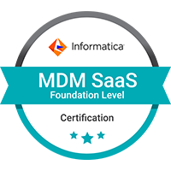

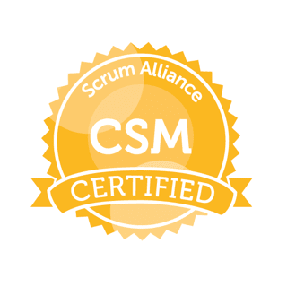
Email: pa1.jalla9@gmail.com Contact no: 732-213-9725
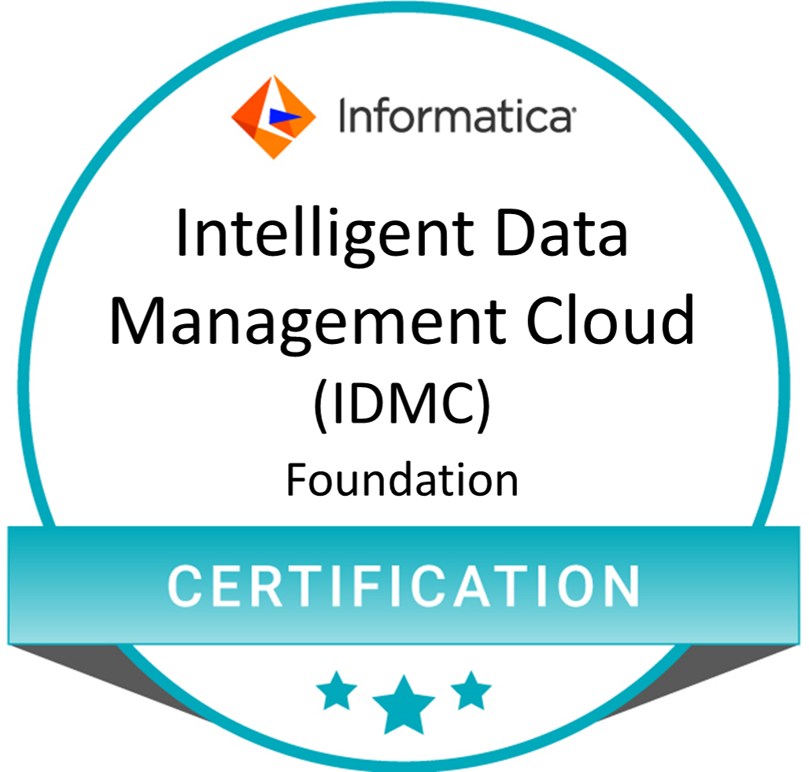


Professional Summary

- Passionate and results-driven Senior Product Manager/ Owner & Project Manager with 14+ years of experience in software industry in managing various software & web applications for Banking and finance, Compliance, payroll, payments, freelancing, Pay Cards & FinTech.
- Certified CSM® & PSPO™ professional with in-depth understanding of Agile practices and methodologies, product management, processes, scrum, release management, Software Development Lifecycle (SDLC).
- Leveraging my Certified ScrumMaster® and Professional Scrum Product Owner™ certifications, i have a firm grasp on the value drivers of any product, and a keen sense of how to use agile practices and Scrum to maximize the value of the product.
- Lead product development from ideation to product launch, working closely and coordinating cross-functional teams, including design, engineering, testing, analytics, data science teams, marketing and sales teams.
- Expertise in creating Product Roadmap, Product Backlog, User stories, Requirement Specification documents.
- Skilled in leading Agile ceremonies such as Sprint planning, daily stand-ups, reviews, retrospectives, Backlog Refinement meetings, Story writing workshops and more.
- Responsible for collecting business requirements and translating them into various artifacts such as Business requirement documents (BRD) & Functional requirement documents (FRD), Use Cases, Test Plan, Test Cases, UI screen mock-ups, and Migration requirements and to ensure that the requirements are correctly conveyed to development team.
- Successful track record in leading multiple cross- functional teams to deliver complex projects on time.
- Proven excellence in delivering high-quality software products within budget and timeline constraints.
- Good Knowledge on ETL tool, Informatica, Robotic Process Automation(RPA) tool, Blueprism and Generative AI concepts.
- Skilled at transforming complex datasets into valuable insights and actionable product features by optimizing data collection, processing and visualization using ETL Tools.
- Led the development of a Robotic Process Automation(RPA)-based recommendation engine, improving product personalization and eliminating the non-value-added work, driving operational efficiency for users.
- Highly passionate in translating machine learning (ML) and Artificial Intelligence (AI) concepts into actionable product features solving real-world problems.
- Good experience in Payroll, Compliance, Fraud, Payments, Pay cards & FinTech platforms including banking, cards, reconciliation and payment gateways.
- Experienced as a Product Analytics lead, led the integration of a third-party analytics tools like Looker service(from Google Cloud platform) & Tableau into the product for WorkMarket(WM) & Oracle case management, resulting in data accuracy and actionable insights.
- Utilized data analytics and user feedback to make data-driven decisions and continuously improve product performance.
- Demonstrated experience and understanding in AWS cloud services, including EC2, S3, EBS, EFS, RDS, IAM and more, to optimize scalable and cost-effective solutions.
- Implemented agile methodologies, including Scrum and Kanban for Change & Defects Management, improving team efficiency and product delivery speed.
- Proficient in using JIRA and hands-on experience in facilitating Agile methodologies, my expertise lies in facilitating communication, stakeholder management, and fostering a culture of continuous improvement.
- Prioritize Product backlog items, other tasks and workloads in order of importance and possessing superb decision-making skills.
- Proven track record of working with Agile teams, both onshore and offshore, in a cross functional development team setup, ensuring seamless collaboration and product delivery.
- Highly motivated, result oriented product manager with never ending willingness to learn and improvise.

Summary - Tools, Applications & Skills

Design & Strategy : Product Roadmap, Product Release, Agile Methodologies, Sprint Planning, Capacity Planning, Daily stand-ups, Reviews, retrospectives, Backlog Refinements, Story writing ,Project Portfolio Management, User Interface (UI) Design, backlog management, BRD, FRD, Use Cases, Test Plan, Test Cases, EPICS to user stories, Cross- functional team collaboration, Stakeholder management, Continuous improvement, Change & Defects Management, Product Analytics, Robotic Process Automation.
Development : Informatica, Azure, AWS DevOps, API, SQL Server, ETL.
PM Tools : Jira, Confluence, Scrum, Kanban, Microsoft Project.
Applications : OFCCM(Oracle Financial Crimes & Compliance Management), NICE Actimize, Archer, Mantas (Oracle AML software), Norkom, LexisNexis, World check, Dow Jones, OWS-Oracle Watch list Screening, Run, Workforce Now, ProjectDox, Accela, Finnacle, Working level knowledge on SWIFT (Society for Worldwide Interbank Financial Telecommunications) Alliance Messenger.
Analytics & Visualization : Google Analytics-Looker(GCP), Tableau, Visio.
Automation : Blue prism.

Scholastics

2009- 2011 MBA (Finance) 8.04
PSG Institute of Management, Coimbatore (CGPA)

2004-2008 BE (Electrical & Electronics Engineering) 67.74%
Sir C R Reddy College of Engineering, Eluru

Certifications

- Professional Scrum Product Owner™ (PSPO) certification issued by Scrum.org.

- Certified ScrumMaster® (CSM®) issued by Scrum Alliance, Inc.

- Microsoft certified Azure Cloud fundamentals.

- Informatica certified Intelligent Data Management Cloud (IDMC) Certification.

- Informatica certified Master Data Management SaaS Foundation certification.

- Certificate from ACAMS on completing Transaction Monitoring course.

- National Stock Exchange certified Capital Market Professional (NCCMP), NCFM Course.

Professional Experience

DC Department of Buildings (DOB)- OIS May 2024 – Present

Senior Product Manager – Permitting & Enforcement project Washington DC

- Leading the end-to-end migration of a major ePlan review & document management software product, ProjectDox from an on-premise solution to a SaaS-based model, improving system scalability and reducing infrastructure costs.
- Involved in enterprise-level application integration project by migrating Accela, from an on-premise solution to a Azure cloud SaaS-based model, which helped to deliver improved insights, visibility, and productivity across the DOB and its sister agencies.
- Managed the development of EMSE scripts in Accela for data manipulation and transformation of permit info, thus improving data quality and efficiency in ProjectDox.
- Engaged with cross-functional stakeholders, including senior level executives, IT, vendor development teams and customer support teams, to define requirements, establish timelines, and ensure alignment on SaaS migration goals and objectives.
- Managed the brand new enforcement inspection system and its related inspection mobile app with CityGov vendor services, negotiating the requirements and ensuring the platforms aligned with long-term business goals and customer needs.
- Led the integration of enforcement inspection system with CRM/CX platform- Kustomer.
- Managed API development lifecycle, from requirements gathering, API documentation to deployment and maintenance.
- Designed the payloads to optimise the data exchange between the enforcement inspection system and CRM during API interactions, including both requests and responses.
- Defined and prioritised API features based on business needs and customer feedback.
- Mentor business/test analysts, guide and lead analysis.

ADP Oct 2017 – Apr 2024

Senior Product Manager – Payroll Compliance project Hyd, Chandler, AZ

- End-to-End Global Product Ownership for 3 different AML applications Transaction Monitoring (TM), Work Market (WM) & Customer screening(CS) covering six regions (US, UK, CA, AU, FR & NL) across the globe, complying with U.S. Department of the Treasury’s, Office of the Comptroller of the Currency (OCC) regulation requirements.
- Led the product development of automated case management AML & Fraud applications from inception to successful launch, resulting in over 50% reduction in operational costs within the first year and also 25% improvement in user satisfaction and engagement.
- Skilled in leading Agile ceremonies such as sprint planning, daily stand-ups, reviews, retrospectives, and more.
- Managing the product through all phases like Discovery, Scoping, Planning, Scheduling, Testing, Tuning, Go-Live & Retuning.
- Collaborated with stakeholders to define product vision, roadmap, and prioritisation, ensuring alignment with business goals and user needs.
- Conducted meetings and one on one discussions with stakeholders for gathering the requirements in most comprehensive way in form of both user stories and functional specifications.
- Elicit the requirements and translating them to ensure that the requirements are correctly conveyed to development team during Agile Sprint meetings.
- Managed backlog and sprint planning, maintaining a high level of transparency and communication with the development team.
- Worked closely with development teams to refine product backlog, ensuring timely delivery of high-quality software releases.
- Drafting Release notes for project Go-Live and obtain sign-off from business stakeholders.
- Created the test data and test cases for Functional testing & User Acceptance Testing (UAT).
- Facilitated communication between development teams and business users to ensure successful product go live and post-go live support.
- Expert in analyzing the applications during tuning phase and adjust the rule parameters and thresholds appropriately to make the system generate right cases.
- Conducted market research and analysis to identify current trends, policies, regulations, industry best practice and opportunities, enabling the delivery of innovative features.
- Led the integration of a third-party analytics tool(Looker-from Google) into the product for WM, resulting in a 25% increase in data accuracy and actionable insights. Utilized data analytics and user feedback to make data-driven decisions and continuously improve product performance.
- Maintaining a map of all TM systems deployed across the group globally and develop and drive global standards across group monitoring systems to eliminate money movement Fraud and money laundering.
- Initiated and prepared the training content and conducted training sessions to development team & stakeholders which made them to get the awareness of the new application functionality, the rules, system logic, process flows and policies.
- Implemented agile methodologies, including Scrum and Kanban for Change & Defects Management, improving team efficiency and product delivery speed.
- Own and drive high impact projects that leads to application enhancement, operational efficiency & betterment of process.
- Collaborated closely with UX designers and engineers to create intuitive user interfaces and enhance overall user experience.
- Conducted regular user interviews and usability tests, gathering insights for feature enhancements and identifying pain points.
- Led the development of a Robotic Process Automation(RPA)-based recommendation engine, improving product personalization and eliminating the non-value-added work, driving a 30% increase in operational efficiency for users. This also, resulted in the integration of cutting-edge features and a 40% reduction in rework for business application users.
- Developed and maintained strong relationships with key stakeholders, conducting regular meetings to gather feedback and address concerns.
- Collaborated with business stakeholders across various international locations (US, UK, CA, AU, FR & NL) and interacting with all levels of management to define project scope, clarify/prioritize requirements and manage expectations throughout the development lifecycle.
- Implemented Agile metrics and dashboards, providing real-time project status updates to stakeholders and enabling data-driven decision-making.

HSBC. Aug 2015 – Sept 2017

Scrum Master/Agile Project Manager – Financial Crimes Compliance project

- Managed the delivery of a high-visibility, enterprise-level project(Norkom to Oracle transition), successfully delivering it within budget and on time.
- Successfully implemented Agile scrum frameworks for development teams, allowing for increased efficiency and productivity by 30%.
- Facilitated Agile ceremonies such as daily stand-ups, sprint planning, sprint retrospectives, demos, and reviews, to ensure all objectives were met and the project progressed on schedule.
- Managed requirements for Name screening application (OWS) integrated with retail core banking system for HSBC and developed high-quality user stories by collaborating with the product owner and organizing effective meetings to discuss and refine user stories.
- Assisted Product Owner in digital product development by providing guidance to development team members regarding their tasks and responsibilities.
- Interact with business stakeholders and handling enquiries to act as the face of the business.
- Collaborated with stakeholders and business sponsors to proactively identify risks and dependencies for the project which reduced the chance for costly delays and errors.
- Monitored sprint progress, identified any impediments, created project and sprint reports and reported project updates to the stakeholders effectively to provide visibility of the project’s overall performance.
- Enhanced collaboration between cross-functional teams and increased knowledge sharing across development team by introducing new processes and systems.
- Reduced the number of blockers by 50% and increased the team's ability to deliver high-quality features by introducing Scrum of Scrums (SoS)
- Arranging & chairing weekly team meetings, focusing on targets, achievements & new initiatives, and appreciate the team members to create a positive working environment.
- Provided guidance, coaching and training to team members on Agile practices and promoting good work practices to build a positive rapport with team.
- Implemented a continuous improvement program, resulting in a 25% increase in team productivity and a 50% reduction in rework for business application users.

ICICI Bank April 2011 – Aug 2015

Role: Product Owner - Wire Transfer & Remittance products

- Responsible for developing and executing a product roadmap to drive revenue growth and customer satisfaction of Wire transfer & M2I products.
- Managed the product roadmap and prioritized product features working closely with stakeholders for requirements elicitation & elaborated the requirements in form of use cases and obtain sign-off.
- Defined product requirements and user stories, working with stakeholders to reengineer and develop a product that met customer needs and business objectives, resulting in a 30% increase in revenue.
- Managed the product backlog and facilitated sprint planning working closely with development team to refine product backlog.
- Monitored sprint progress and managed stakeholders, ensuring that the team met its goals and that stakeholders were kept informed and engaged.
- Collaborated with stakeholders to prioritize product features based on customer feedback and market trends, resulting in a 30% increase in user engagement.
- Monitored product performance and tracked key metrics and user feedback, resulting in a 20% increase in customer satisfaction.
- Led the development of Automation of bulk wire process(Corporate based wire transfer product) which involves, switching the manual processing of the transactions to automated processing, resulting in a 40% increase in business team’s productivity and a 20% reduction in payment processing turnaround time(TAT).

Initiatives

ADP (2019- 2021) “FCRM Transaction Monitoring Automation”

Purpose: The aim of the project is to improve the overall efficiency of the FCRM TM system by eliminating the non-value-added work there by concentrating on what is value to the transaction monitoring process.

Execution & Outcome: Visited US during early 2019 with the objective of studying various business functions and payroll systems, gathered information & evaluated the requirements for output.
Workflow enhancements using Robotic Process Automation (RPA) solution and data analytics created a positive impact to business users by leading to elimination of manual work. The time savings/ROI for this project is 11,000 hours/annum which is equivalent to more than 5 FTE.

HSBC (2016) “OWS Alerts Automation”

Purpose: The aim of the project is to eliminate False Positives from the significant volumes that exist in Name screening system. Thus, business users spend majority of their time working on true alerts helping to meet the SLA and TAT to as per the OCC regulations.

Execution & Outcome: Reengineered the process and looked at alert logics built in OWS application to identify gaps. Collaborated with HSBC BI team with proper scenario wise analysis on each rule to build the internal logics in OWS to close false positive alerts automatically without much manual intervention.
This led to elimination of 300,000 False positive alerts in the system. The time savings/ROI for this project is 75,000 hours/annum which is equivalent to more than 37 FTE.

